Retail Business Performance & Profitability Analysis

## Introduction

In the highly competitive retail sector, data-driven insights are vital to maximize profitability, manage inventory efficiently, and cater to seasonal demand. This project aims to analyze transactional retail data to identify profit-draining categories, understand inventory turnover, and highlight seasonal trends to guide strategic decision-making.

## Abstract

The project analyzes transactional data using SQL, Python (Pandas, Seaborn), and Tableau. It focuses on identifying underperforming product categories and sub-categories by calculating profit margins, examining the relationship between inventory days and profitability, and uncovering seasonal product patterns. The findings are visualized through an interactive Tableau dashboard, supporting better business decisions related to inventory and sales strategies.

## Tools Used

- SQL: Data cleaning and profit margin calculations  
- Python (Pandas, Seaborn): Correlation analysis between inventory days and profitability  
- Tableau: Interactive dashboard creation for visual insights

## Steps Involved in Building the Project

1. Data Import & Cleaning:  
 - Loaded raw transactional data into SQL  
 - Removed null and duplicate records  
 - Standardized date formats and cleaned missing values  
  
2. SQL Analysis:  
 - Calculated Profit Margin = (Sales - Cost) / Sales for each category and sub-category  
 - Aggregated total sales, cost, and profit by product type and region  
  
3. Python Correlation Analysis:  
 - Imported cleaned data into Pandas  
 - Calculated Inventory Days = (Average Inventory / Cost of Goods Sold) * 365  
 - Used seaborn.heatmap() to visualize correlations  
 - Found strong inverse correlation between inventory days and profit margin  
  
4. Dashboard Development in Tableau  
  
5. Strategic Insights:  
 - Identified slow-moving items with high inventory days and low margins  
 - Suggested promotional strategies for overstocked but in-demand items  
 - Flagged profit-draining categories with high return rates

**Key Insights**

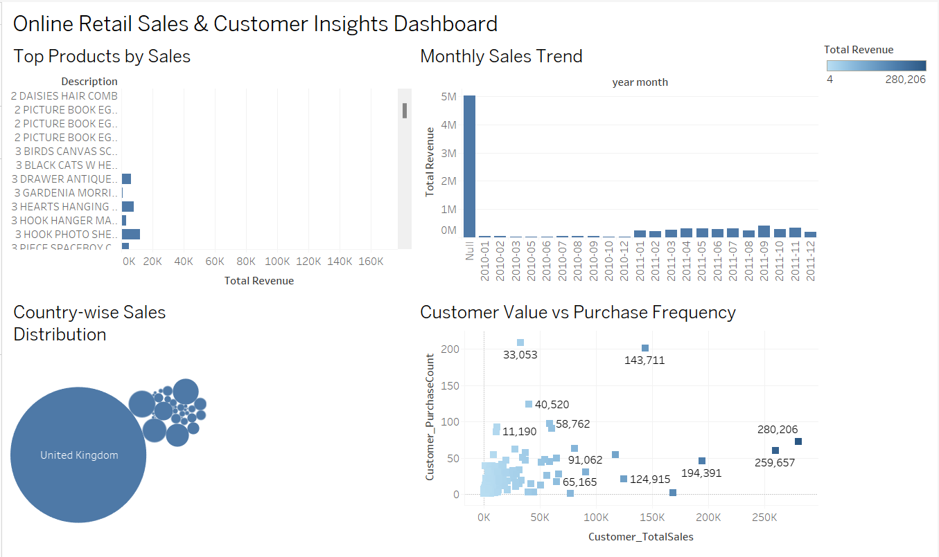

## Conclusion

This end-to-end project demonstrates how data analysis can improve profitability in the retail domain. Through SQL-based computations, Python correlation analysis, and Tableau visualizations, we were able to uncover actionable insights for better inventory planning and category management. The final dashboard empowers stakeholders to make informed decisions by monitoring key metrics across time, region, and product lines.